DI GOOD PLACE DEM

USER MANUAL

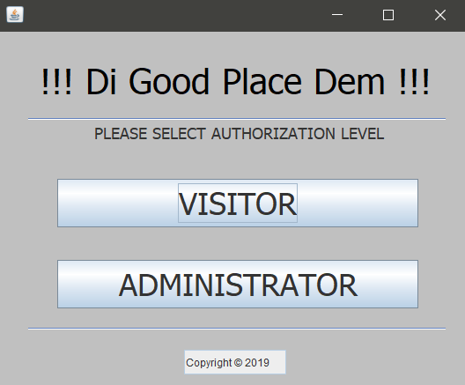

Productions Team:

* Development Team
* Tyrone Wallace (Student)
* Dimitri Russell (Student)
* Reinaldo Pino (Student)
* Development Lead
* Mr. Gilroy Gordon (Lecturer)

**Contents**

1. Overview................................................................................................................................. 1

1.1 Scope................................................................................................................................ 1

1.2 Purpose............................................................................................................................. 1

1.3 Organization..................................................................................................................... 1

2. Application Users and Steps.................................................................................................. 2

2.1 Visitor Functionalities..................................................................................................... 2

2.2 Administrator Functionalities......................................................................................... 2

Bibliography ........................................................................................................................... 12

**1 Overview**

This section presents the scope, purpose and organization of “Di Good Place Dem” System. The system is a java developed application with a jar execution file.

* 1. **Scope**

This application is aimed at tourists and residents of Jamaica to be use for a better Jamaican travel experience. The Jamaica Cultural Development Agency working with the Jamaica Tourist Board and Sangsters International Airport has decided that with the increase of AirBnB experiences available, tourists should have easy access to information that will provide insight on attractions. Moreover, they have agreed that this is a wonderful opportunity to re-engage our linguistic culture. The application was designed to display various Jamaica attractions for Visitors and manipulation of the system by its Administrator, accompanied by various functionalities and non-functionalities for both Visitor and Administrator users.

**1.2 Purpose**

The purpose for this system is to introduce a higher level of understanding of Jamaica attraction and Jamaican culture. The system was designed to target tourists and citizens to have more fruitful experience as they become equipped with the valuable information of Jamaican Attractions that system will provide.

**1.3 Organization**

The system was organized by three (3) students from the University of Technology, Jamaica. Instructions for the system’s functionalities and non-functionalities were instructed through a second year course offered by the School of Computing and Information Technology (SCIT), as an assignment for the module called Data Structures. The Development Lead for this system was the Lecturer/ Tutor Mr. Gilroy Gordon. The names of the students in question are as follows:

* Tyrone Wallace
* Dimitri Russell
* Reinaldo Pino

**2 Application Functionalities**

The system has two (2) types of access levels for different users. These include:

* Visitor
* Administrator

**2.1 Visitor Functionalities**

**STEP 1** – Click Visitor:

The Visitor access level is open to anyone with access to the system. The user can access the Visitor options by clicking the Visitor button at the launch of the application.

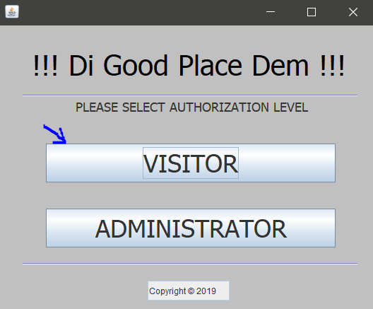

Upon completion of the first step the Visitor will be greeted by a well customize display with clear and user friendly navigation buttons for control.

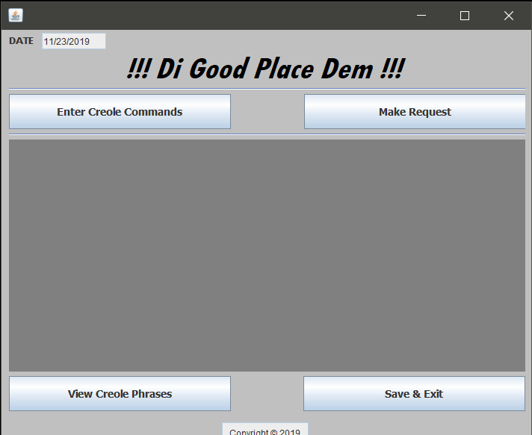

**STEP 2** - Creole Commands, Make Request and View Creole Phrases:

OPTION 1 - Creole Commands:

The first button on the Visitor display is the “Enter Creole Commands”. This button showcases the commands the Visitor can use. The commands are written in creole.

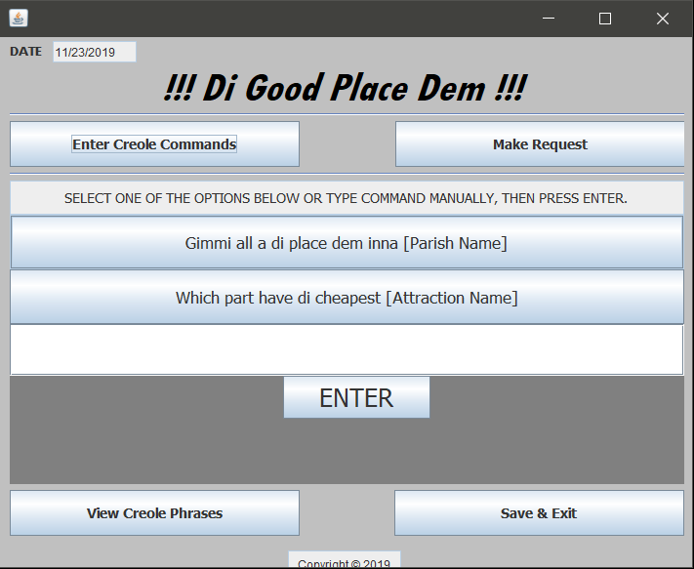

The translations for the two commands are as follows:

|  |  |
| --- | --- |
| **Creole Commands** | **English Translations** |
| Gimmi all a di place dem inna [Parish Name] | Give me all the places that are in [Parish Name]” |
|
| Which part have di cheapest [Attraction Name]” | Which attraction has the cheapest [Attraction Name]” |

The Visitor has the option to manually type the creole commands or click on the buttons provide to insert the command in the text field below the commands button.

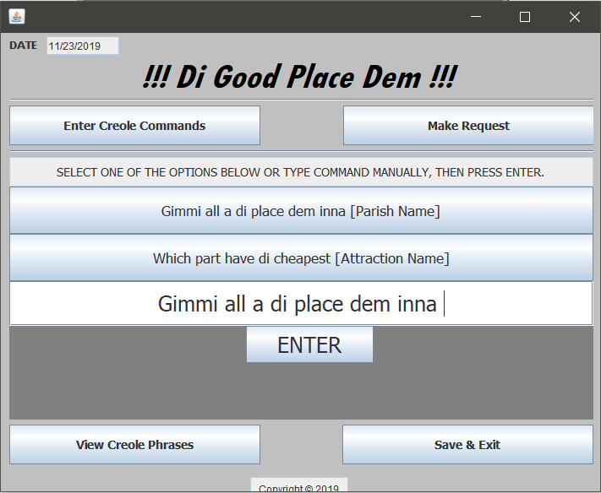 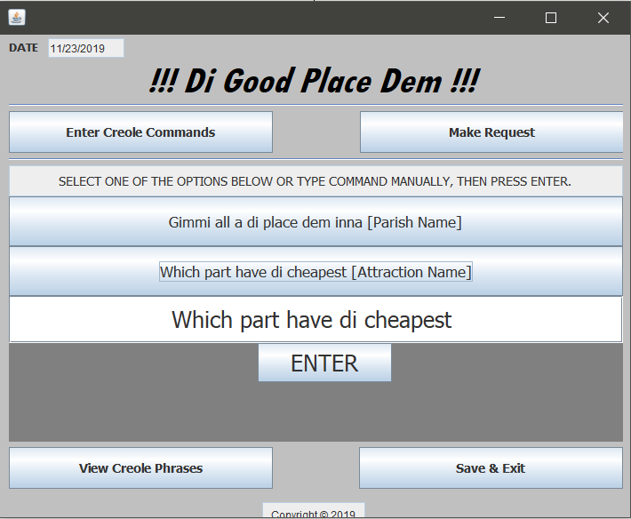

Upon completing the text field by appending the appropriate information for the correct command, for example parish like ‘Kingston’ for first command and ‘River’ for second command, the Visitor must click the ‘Enter’ button to complete the function. This action will enable the system to take the necessary actions.

OPTION 2- Make Request:

The second button, ‘Make Request’ enable to visitor to make a request about an attraction. At this section, the visitor will be required to fill out the following forms to complete the request.

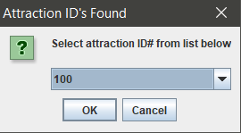

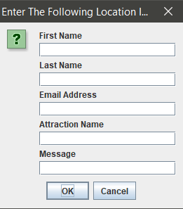

OPTION 3 - View Creole Phrases:

This option is design to engage Visitors in the understanding of the language of the Jamaican people, Patois. When this button is clicked the Visitor will be encountered by a list of Jamaican phrases and their English translations.

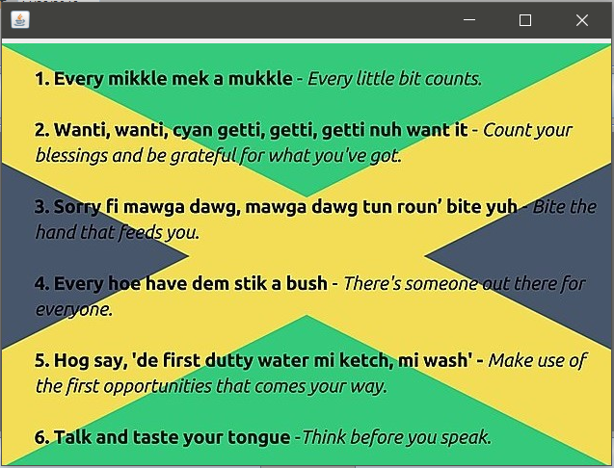

OPTION 4 – Click Save & Exit:

This option is crucial for the full experience of the system whereby all the changes made will be permanently saved and the application will close.

**2.2 Administrator Functionalities**

OPTION 1 – Click Administrator:

The Administrator access level is not open to the public, whereby an administrator username and password key is needed for access upon the click of the Administrator Button.

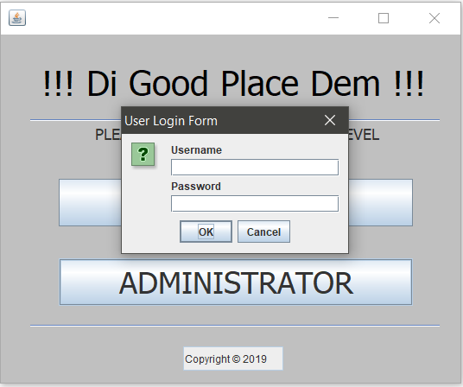

Upon completion of the login form the Administrator will be greeted by a welldesigned display, as show below.

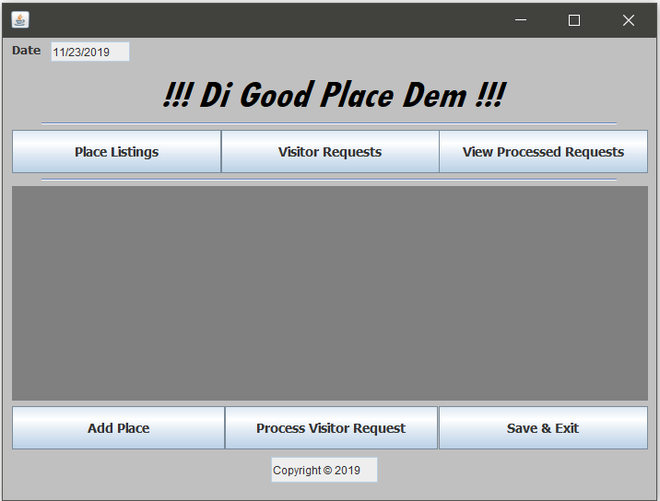

OPTION 2 – Click Place Listings:

This button enable to Administrator to view all the places listed in the system in the center of the application display.

OPTION 3 – Click Add Place:

This option allows user to add an attraction to the application, increasing the application’s database of attractions to choose from.

OPTION 4 – Click Visitor Request:

This option grants the Administrator access to the list of requests made by Visitors.

OPTION 5 – Click Process Visitor Request:

This option enable to Administrator to process the oldest request made. The oldest request will be removed from the request listings and pushed onto the Process Request Listings.

OPTION 6 – Click View Process Request:

This option grants the Administrator access to the Process Request Listings, whereby the list will be displayed on the screen.

OPTION 7 – Click Save & Exit:

This option is crucial for the full experience of the system whereby all the changes made will be permanently saved and the application will close.

**Bibliography**

Rogers, M. P. (2001). Java software solutions: Foundations of program design - 2nd edition / an introduction to object-oriented programming with java - 2nd edition / java elements: Principles of programming in java.*Mathematics and Computer Education, 35*(3), 269-274. Retrieved from https://search-proquest-com.ezproxy.utech.edu.jm/docview/235923976?accountid=35539

Wein, M., Cowan, W., Gotlieb, C. C., Schaeffer, J., Peltier, J., Munro, J. I., . . . Cockburn, B. (2019). *Computer science* (English ed. ed.). Toronto: Historica Canada. Retrieved from https://search-proquest-com.ezproxy.utech.edu.jm/docview/2316659796?accountid=35539